### LifestyleMatters Logo 4#E1B.eps

### 5 Ways to Control Portion Size:

1. Don’t eat out of the bag: It is easy to eat multiple servings.
2. Drizzle—don’t dump—salad dressing. The salad will have more flavor than just fat.
3. Use smaller plates and bowls. You will be less tempted to overload your plate.
4. Use oily spreads on breads sparingly—about the size of your thumbnail.
5. Remember to keep choices low in fat and high in fiber!

### 6 Calorie Mistakes You Can Avoid:

**1. Beverages**

Water is the best beverage for health and to satisfy thirst. Soda, juice, and sweetened drinks can sneak hundreds of calories into your diet. Some lattes are 1,000 calories! Get 8-10 glasses of water a day.

**2. Crackers and chips**

It is easy to fill up on chips and crackers—they are easy to grab and eat on the run. But it doesn’t take long to rack up calories, refined carbs, and pounds. Just 6 small handfuls of chips can pack 60 grams of fat.

**3. Baked goods**

Most baked goods look normal when they are actually huge sizes. Consider that cookies or cake for sale in most bakeries are upwards of

500 calories. *An apple is just 80 calories.*

**4. Fried food**

Frying food doubles the calories of just about any food versus eating it plain. *Choose foods that are grilled, steamed, baked or roasted*.

**5. Pizza**

Eating pizza until full can lead to 2 or 3 times the amount of calories you should eat. *Try making your own pizza and loading it with fresh spinach, peppers, , zucchini, and other vegetables instead of heavy cheeses.*

**6. Salad**

Many people get into trouble with salad two ways. First they load up on high fat ingredients like mayonnaise-laden dressings, cheese, croutons or bacon. Second, they tend to eat too little salad - which if low in fat would help displace higher fat/calorie foods. *Eat more salad but make it low in fat and rich in raw veggies and mixed greens.*

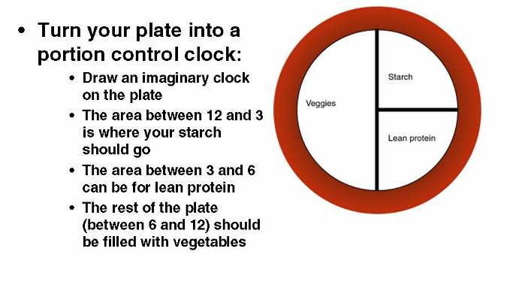

Copyright [www.**LifestyleMatters.com**](http://www.LifestyleMatters.com). 866-624-5433. Used by permission.